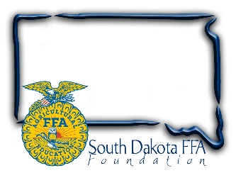
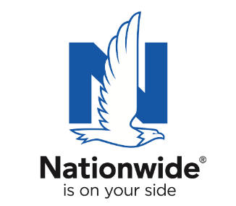
FOR IMMEDIATE RELEASE

February 27, 2024
Contact:
Gerri Ann Eide
gerri@sdffafoundation.org
605-765-4865

Eight South Dakota Agriculture Teachers Named Finalists
for Golden Owl Award ®
Finalists recognized for their contributions and awarded funding to
advance their ag programs
Bath, SD – Educators devote limitless time, and often their own resources, to helping students pursue their passions. To recognize the contributions of South Dakota’s leading agricultural teachers, the South Dakota FFA Foundation and Nationwide are honoring eight exceptional teachers as finalists for the Golden Owl Award.

From Oct. through Dec., 2023, the nominations were collected for the state’s top agricultural teachers from local students, parents, fellow teachers and community members across South Dakota.
South Dakota’s 2023-2024 Golden Owl Award finalists are:
District 1: Fred Zenk, Webster (pictured with Caroline Hansen, SD FFA Leadership & Program Manager and Kim Snell, Dacotah Insurance)
District 2: Josh Johnson, Brookings (pictured with Wyatt DeJong, SD FFA Executive Secretary)
District 3: Clayton Sorum, Tea Area (pictured with Caroline Hansen, SD FFA Leadership & Program Manager)
District 4: Terry Rieckman, McCook Central (pictured with Ray Trudeau, Martin-Trudeau Insurance & Erin Cummings, Nationwide)
District 5: Austin Bishop, Belle Fourche (pictured with Tacha Artz, Fisher Rounds and Mathew Raba, Belle Fource High School principal)
District 6: Brady Duxbury, Wessington Springs (pictured with Mercedes Snedeker, SD FFA Advisor)
District 7: Tara Fastert, Harrisburg (pictured with Wyatt DeJong, SD FFA Executive Secretary)
District 8: Renae Gebhart, Lemmon (pictured with John Dady, Key Agency in Mobridge and Mercedes Snedeker, SD FFA Advisor)

Each finalist was presented with an individualized plaque in front of fellow teachers and students and received a $500 check to support future educational efforts. Next, they’ll be entered into a final selection stage for the chance to be crowned as South Dakota’s Ag Educator of the Year, earning an additional $3,000 Nationwide-funded check and the coveted Golden Owl Award trophy.

“Our teachers are the foundation of the FFA. They inspire our members every day, providing them encouragement and motivation to try new things. They coordinate early morning practices, dedicate weekends to FFA events, model a passion for serving others, and endlessly help students grow their passion for agriculture. We are so thankful Nationwide recognizes the valuable work our teachers do and provides this award,” shares Sandy Osterday, SD FFA Foundation Board President.

Nationwide established the Golden Owl Award to honor the contributions of teachers and support their programs with additional resources to assist their continued educational efforts. This year, the award program honors outstanding ag educators in 11 states: California, Illinois, Indiana, Iowa, Kansas, Missouri, Nebraska, New York, Ohio, Pennsylvania and South Dakota.

“As the need grows for more ag educators across the nation, we are proud to thank and honor these hardworking agricultural teachers for their dedication,” said Brad Liggett, president of Agribusiness at Nationwide. “These educators play a crucial role in preparing students for successful careers in the industry.”

In conjunction with the Golden Owl Award, Nationwide is also donating $5,000 to the South Dakota FFA Foundation to further support the personal and professional growth of students, teachers and advisors alike.

About SD FFA
The SD FFA has 6143 members in 110 high school agriculture education programs. The SD FFA Foundation is proud to support Agricultural Education and the FFA's mission to make a difference in the lives of students by developing their potential for premier leadership, personal growth and career success through agricultural education. For more information about the South Dakota FFA Foundation and South Dakota's FFA programs, visit www.sdffafoundation.org or follow us on Facebook.

About Nationwide
Nationwide, a Fortune 100 company based in Columbus, Ohio, is one of the largest and strongest diversified insurance and financial services organizations in the United States. Nationwide is rated A+ by both A.M. Best and Standard & Poor’s. An industry leader in driving customer-focused innovation, Nationwide provides a full range of insurance and financial services products including auto, business, homeowners, farm and life insurance; public and private sector retirement plans, annuities and mutual funds; excess & surplus, specialty and surety; pet, motorcycle and boat insurance. For more information, visit www.nationwide.com. Follow us on Facebook and Twitter.

###

